|  |  |
| --- | --- |
| **BOA ME**  EMERGENCY RESPONSE SYSTEM |  |

**TABLE OF CONTENT**

Introduction and Goals………………………………………………………………………i

Scope……………………………………………………………………ii

Description…………………………………………………………..iii

Users…………………………………………………………………….iv

Constraints on users…………………………………………….v

Technology and methodology………………………………………………..vi

Project progress………………………………………………..vii

Team…………………………………………………………………..viii

INTRODUCTION

In recent times, crime has become very rampant in our society. A day never goes by without us hearing news of diverse incidence of crime across the world. These crimes range from theft to rape. Our society has become a scary place. Men who are healthy and strong fall victims to crime how much more the weak and physically challenged. The physically challenge, aged and pregnant women are the most vulnerable people in our society and unfortunately, they are the target of the criminals. In cases of disasters such as fire, they are less likely to survive because of their handicap nature.

Pregnant women have had their share of hardships during labor. Many women have lost their lives and babies just because they couldn’t get emergency health care.

Kids are being kidnapped every now and then. Parents can no longer sit at ease without their kids by their side.

According to the U.S government study, people with disabilities such as the blind, deaf and developmentally disabled and kids are 70% more likely to be victims of violent crimes than people without disabilities.

In the past decade, mobile phones were seen and classified as portable communication tools, with the sole capability of making calls, without any physical connection to a landline. Today, tremendous advancements have been achieved in mobile computing industry through the inclusion of accelerometers, GPS systems and touch screens but mobile phones have not succeeded in the aspect of saving lives and eradicating crime completely. Mobile phones draw attention of criminals at the point of attack and is very cumbersome to use for emergency situations. Most parents are not comfortable with their kids handling mobile phones because they are worried about the things their kids could be exposed to.

Due to the advanced nature of computer architectures for embedded systems computing, raspberry pi technology has become well integrated into the very fabric of our modern way of living. Our developed platform is a user- friendly device which will help improve the availability, affordability and effectiveness of healthcare delivery, crime reduction and live saving.



**Study Objectives**

The general and specific objectives of the project are listed below:

**Global (General) Objectives**

The main objective of the project is to create a device that will enable users send effective and efficient messages during times of distress with ease.

**Specific Objectives**

In order to attain the general objective, the following list of specific objectives:

* To develop a functional communication device.
* To develop a user- friendly device.
* To enable users send messages via buttons to the police, ambulance or fire service.
* To enable users send their geographically location automatically when in need of help.

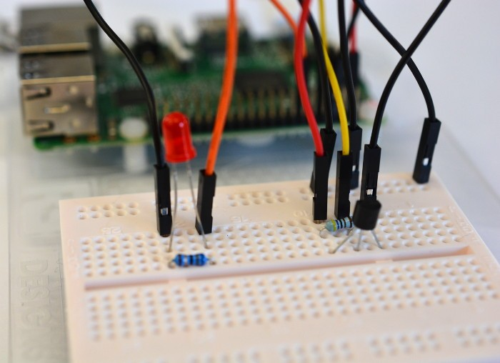

SIGNIFICANCE OF PROJECT.

Boa me aims at creating a convenient and fast way of reaching out for help in moments of distress such as an attack, health crisis or fire outbreak. This technology is fast and very easy to use hence will be very helpful to the physically challenged, kids, aged and pregnant woman in times of crisis. It takes less than 5 seconds to call for help without having raise any alarms or explain any details. Your geographical location will be captured and sent to the recipient of the message within the shortest possible time.

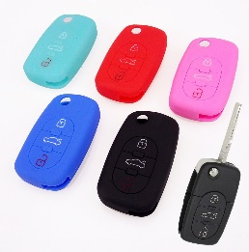 

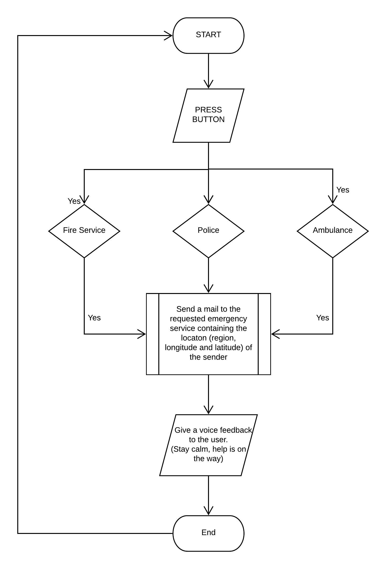TARGET GROUP/USERS

BOA ME emergency signal device will be extremely beneficial to everyone and at any place most especially **the physically challenged, minors, aged and** **pregnant women**. This device could be imbedded case or container that draws less attention. The device is portable and very handy and could be used by anybody without much stress. All one needs is to just press a button depending on their emergency.

CONSTRAINTS

* Users will need to have a power supply for their device.
* The device may appear bulky for minors.

## **METHODOLOGY AND TECHNOLOGY**

## 

## **Methodology**

The software development methodology employed for this project is the agile development. Beck et al. (2001) states that agile development is a software development methodology that values:

* Individuals and interactions over processes and tools
* Working software over comprehensive documentation
* Customer collaboration over contract negotiation
* Responding to change over following a plan

Agile development is selected because the technology is changing fast. Agile development reduces development time. Changes to the requirements are accommodated easily because the software is delivered in small, incremental releases. Therefore, the progress can be measured because of faster delivery of smaller working releases of the software. Moreover, testing is continuously throughout the development due to software is delivered in small, incremental releases. Therefore, bugs and problems can be easier to find.

TECHNOLOGIES

Python

Raspberry pi

GPIO

API

**POSSIBLE IMPROVEMENTS**

The device could be enhanced by adding a GPS tracker to the device to enable the user to be tracked once the person is found to have gone missing even if the person is unable to send a message to indicate they are in need of help.

The Boa me device could be made chargeable and more handy in future.

The model or design (physical) could be enhanced and made attractive.

**THE TEAM**

FRANK AKUMBISSAH

NAJAT BOYAPINNI MUSAH

FREDERICK ENNIN

KWABENA AFRIYIE-GYAMFI